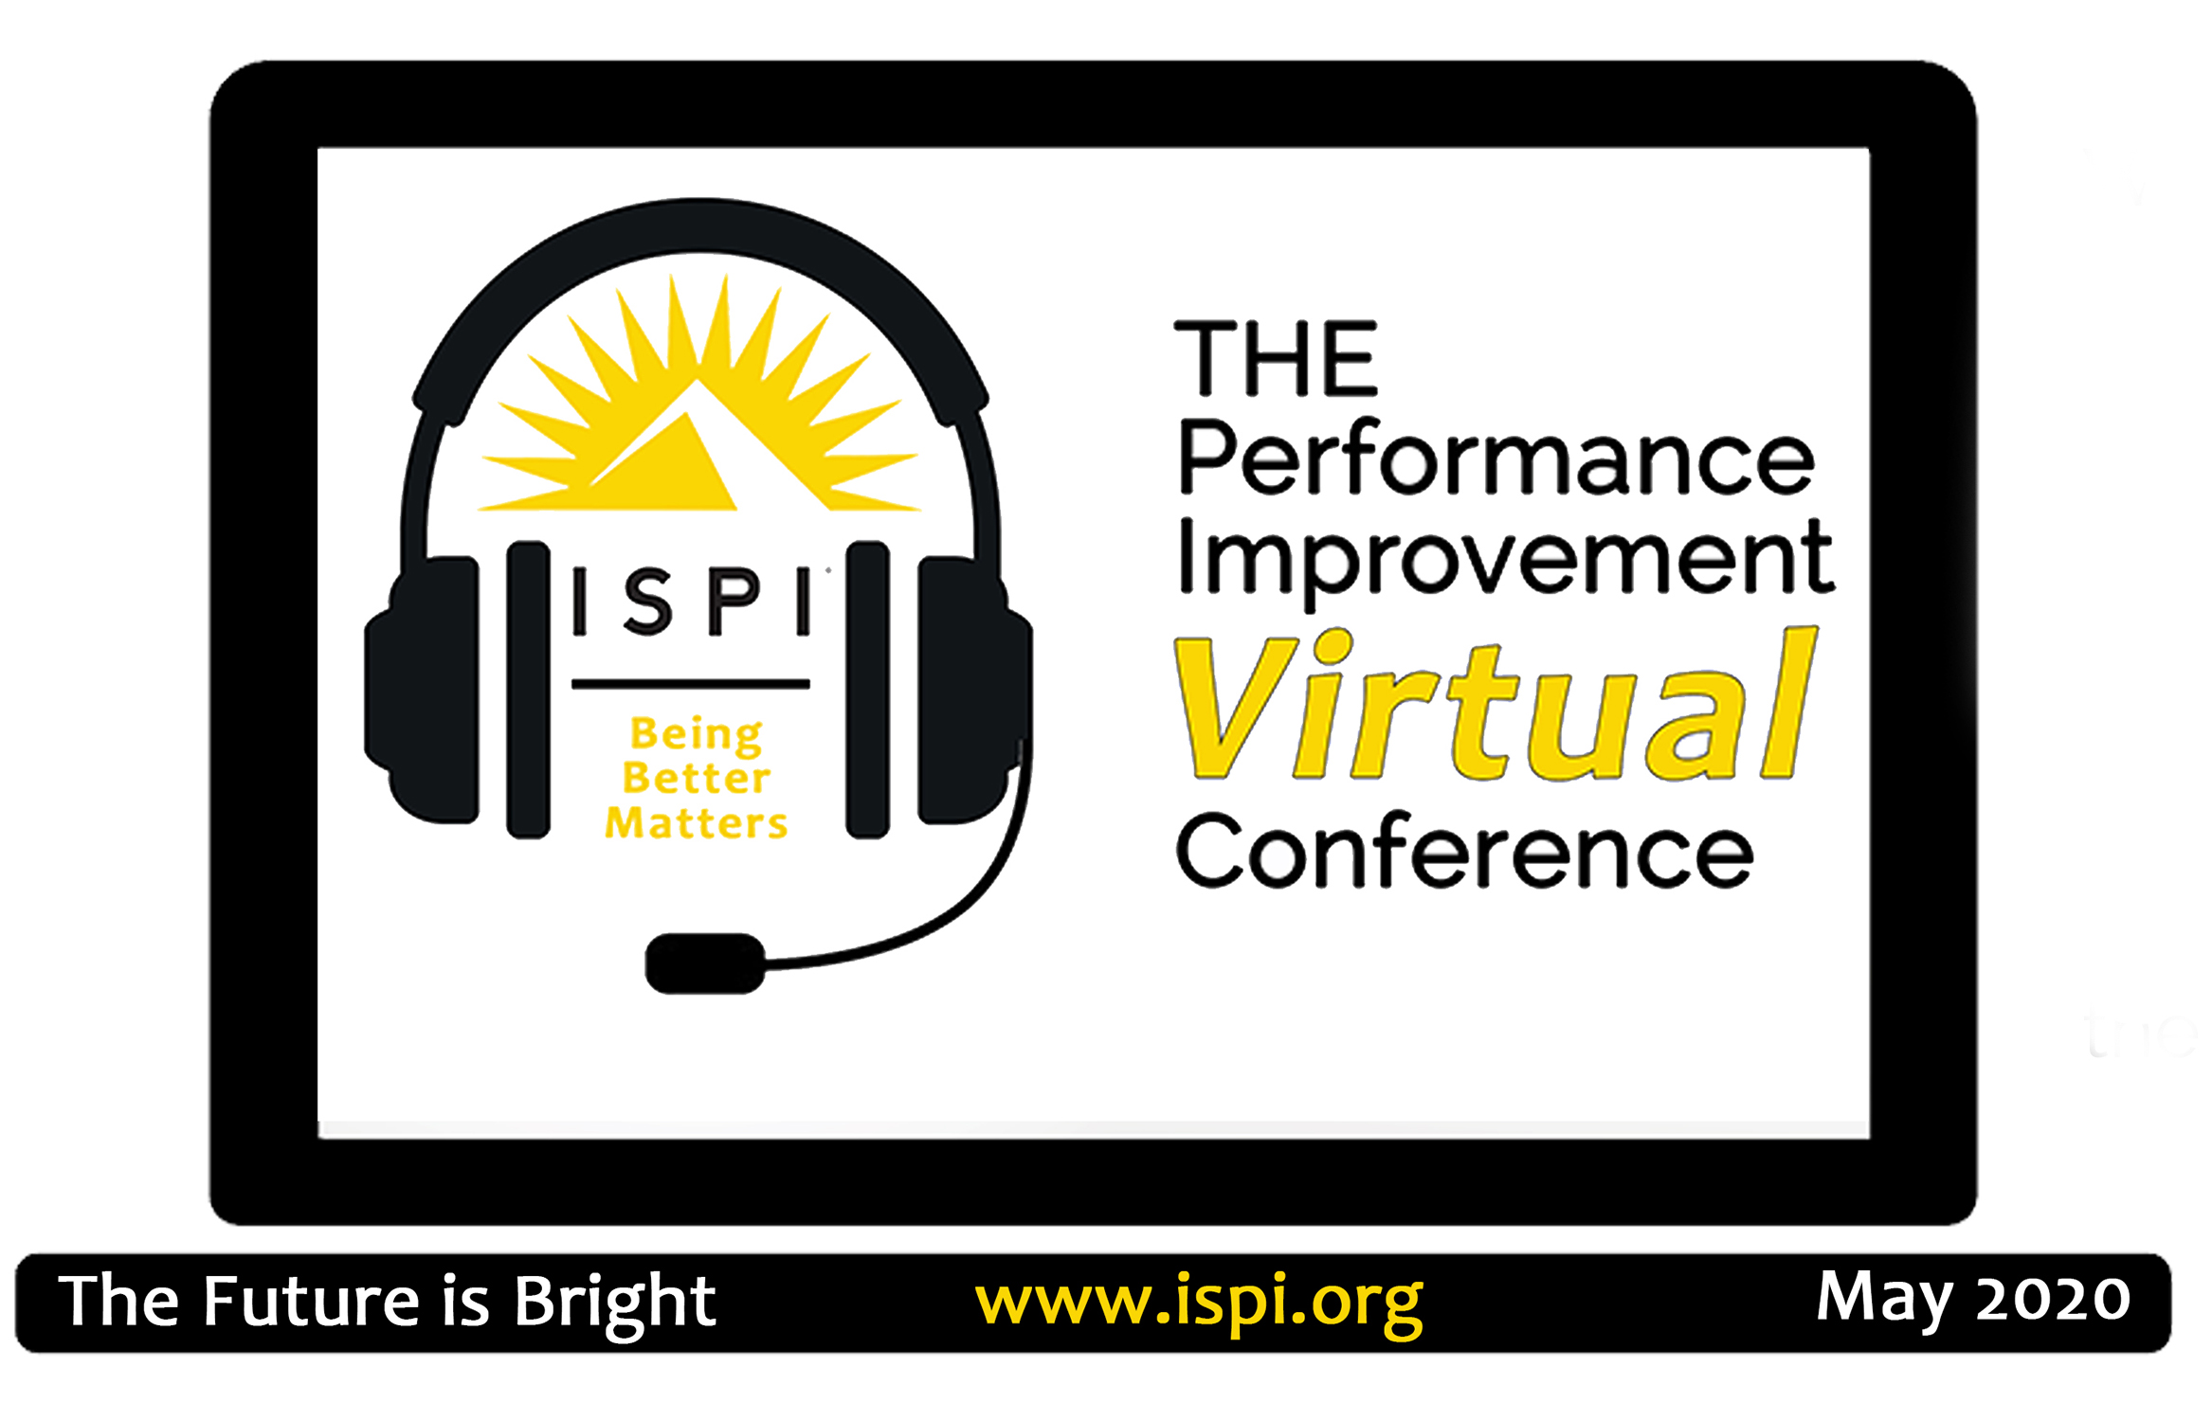
THE Performance Improvement Conference
Virtual Conference Schedule

ALL TIMES EDT

THURSDAY, APRIL 30, 2020
1:00p – 3:55p | DEEP DIVE: The Future Of Work – How Humans Work Effectively With Advancing Technologies© | Kenneth Roberts
4:00p – 4:55p | The Hidden Cost of Automation on Critical Thinking | Judy Hale/Veronika Shestak

FRIDAY, MAY 1, 2020
1:00p – 1:55p | Making the Leap: Correlation to Causation | Bonnie Beresford
2:00p – 2:55p | The Need to Localize a Global Culture Change | Lisa Bradley-Mitchell
3:00p – 3:55p | Increase your Performance Improvement Effectiveness with Change Management | Dawn Snyder
4:00p – 4:55p | Insider Effects: Empathy and the Needs Assessment Participant Experience | Kim Pinckney-Lewis/John Baaki

WEDNESDAY, MAY 6, 2020
1:00p – 3:55p | MASTERS SERIES: Roger Kaufman | Roger Kaufman
4:00p – 4:55p | TBD | TBD

THURSDAY, MAY 7, 2020
1:00p – 2:55p | KEYNOTE: The Future of Work | Daniel Negroni
3:00p – 3:55p | Fourth Industrial Revolution: Effective Workplace Solutions | Judy Hale
4:00p – 4:55p | The Learning Leader Job is Not Easy! | Lisa Toenniges

FRIDAY, MAY 8, 2020
1:00p – 1:55p | Transformation - Inevitable Annoyance or Fulfilling Opportunity? | Kerry Hearns-Smith/ Marnie McCown
2:00p – 2:55p | Empathic Design: Embracing Compassion and Care; Engaging in Performance Improvement | John Baaki
3:00p – 3:55p | Key Thinking Strategies of Phenomenal Leaders | Kim Ades
4:00p – 4:55p | Storyboarding: Build Your Skills | Lisa Giacumo

WEDNESDAY, MAY 13, 2020
1:00p – 3:55p | MASTERS SERIES: Rose Benedicks | Rose Benedicks
4:00p – 4:55p | TBD | TBD

THURSDAY, MAY 14, 2020
1:00p – 2:55p | DEEP DIVE: The Revolutionary Power of WE | Peter Baverso/Z. Chaudhary
3:00p – 3:55p | Breaking Bad-Successful Bright Future or Down the Tubes? | Eileen Maeso/ Douglas Craft
4:00p – 4:55p | Survey Design and Data Analysis: The Nuts and Bolts | Yonnie Chyung/Douglas Hutchinson

FRIDAY, MAY 15, 2020
1:00p – 1:55p | Leading in a Complex World - What Makes a Difference? | John Lazar
2:00p – 2:55p | What’s the Difference?? Using Six Sigma to Determine a Change | Leanne Jensen
3:00p – 3:55p | Measuring the ROI of Future of Work Projects | Jack and Patti Phillips
4:00p – 4:55p | Digital Fakery and Blurring the Truth: An HPT Approach? | Anne Niccoli

SATURDAY, MAY 16, 2020
1:00p – 4:00p | ISPI ANNUAL AWARDS PRESENTATION (Free and open to all) | Allison Rossett
4:00p – 4:55p | TBD | TBD

WEDNESDAY, MAY 20, 2020
1:00p – 3:55p | MASTERS SERIES: Ellen Wagner | Ellen Wagner
4:00p – 4:55p | TBD | TBD

THURSDAY, MAY 21, 2020
1:00p – 2:55p | DEEP DIVE: Future of ROI | Jack and Patti Phillips
3:00p – 3:55p | Branding for the Performance Improvement Professional | Charlotte Chase
4:00p – 4:55p | Effects on Decisions: Paper vs. Tablet | Anne Niccoli

FRIDAY, MAY 22, 2020
1:00p – 1:55p | Stretching Learning to New Dimensions-From Providing Learning to Facilitating Performance Outcome | Yvon Delat
2:00p – 2:55p | Storyboarding your way to performance | Sue Czeropski/Curtis Pembrook
3:00p – 3:55p | An online master’s-level Career-Coaching Course: Successes and Limitations | Steven Villachica/  Lisa Giacumo/Vicki Steiha
4:00p – 4:55p | Designing Mobile Learning for ROI | Patti Phillips

THURSDAY, MAY 28, 2020
1:00p – 2:55p | DEEP DIVE: The Seventh Box: The Role of Meaningful Relationships in PI | Lisa Bradley-Mitchell
3:00p – 3:55p | Road Map to Building a Consulting Firm: Your Entrepreneurial Journey | Judy Hale/Nancy Burns
4:00p – 4:55p | Communication in Complex Projects and Environments | Barb Seigel

FRIDAY, MAY 29, 2020
1:00p – 1:55p | Design Thinking, the 10 Standards, and Engineering Worthy Performance | Tim Brock
2:00p – 2:55p | Flipped Classroom Flops and Rebounds | Mark Boccia
3:00p – 3:55p | Using a Chatbot for Training Reinforcement | David Livingston
4:00p – 4:55p | How to Utilize RACI and Build High-Performing Teams | Sherry Handcock

